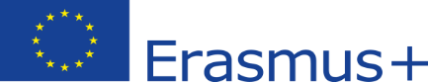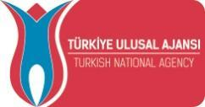

Erasmus+ World KA171 International Credit Mobility
Academic Staff Applications
for the 2025 Spring Semester
2022-1-TR01-KA171-HED-000075524

APPLICATION CRITERIA
The Erasmus+ Teaching Staff Mobility program applications for non-European countries will be taken between 11 November and 13 December 2024
Mobility activities within the framework of this specific call must be completed until 31 July 2025.
Exchange Period: 01 January 2025 until 31 July 2025

Within the scope of this activity, the employee can perform academic duties to receive various teachings (such as on-the-job teaching, observation processes, and organized personnel mobility weeks) to improve their skills in matters related to their current job. This activity aims to increase the quality of the services provided by the personnel in the existing institution and unit, to transfer good practice examples to the institution and unit, and to gain experience in this direction. Conference participation, on the other hand, cannot be supported within the scope of the activity.

1. Partner List and Quotas

Please find the list of countries and partner universities that can be visited under this call and the quotas per region.


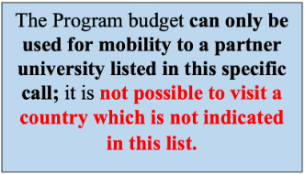
*** An inter-institutional bilateral agreement must exist for teaching activities, and Erasmus + KA171 does not provide funding for Mobility in non-partner universities.
**Concerning the countries that require a visa, applicants are advised to check visa requirements and the deadline before applying for the call.

* Please pay attention to the visa requirements of the country that you select. You can check visa informations at: https://www.mfa.gov.tr/turk-vatandaslarinin-tabi-oldugu-vize-uygulamalari.tr.mfa.

2. Application Conditions (Minimum Requirements)
2.1. Applicants must be members of Altinbas University and they must be actively working at Altinbas University at the time of application,
2.2. Selected candidates are expected to get in touch with their choice of HEI (from the attached list) and receive an acceptance letter stating that the HEI will accept them. The acceptance letter must be received and sent by 31 January 2024 to icm@altinbas.edu.tr.
Academic staff who have not received an acceptance letter by the specified date should contact the Erasmus office to be considered for placement in their second preference, if applicable.
A sample acceptance letter draft is provided below. Acceptance letters are not required to be signed at the rectorate/dean level in the host institutions; it is sufficient to obtain approval from the unit where the activity will take place. It is also possible for host institutions to use their invitation letter formats.
Draft Acceptance Letter (with minimum requirements)
.
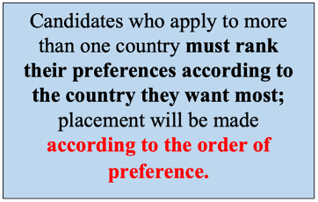

3. Application Procedure & Application Documents
Step 1: Check the Partner list eligible for Erasmus+ funding within this specific call and evaluate which university and country you prefer to visit for the mobility,
Step 2: Obtain an Acceptance Letter. Please see item 2.2. for more details,
Step 3: Fill in the application form and upload your acceptance document. All applications, selections, and placements will be carried out online and through the Turna portal platform initiated by the Turkish National Agency: https://turnaportal.ua.gov.tr/giris?returnUrl=%2F
Candidates can apply for a maximum of 3 preference
Application documents should not be physically transmitted, but only uploaded to the relevant section of the Application Portal.
.
All applications will be evaluated by the Altinbas University Erasmus Office according to fair and transparent selection criteria (please see Section 4 below) and the results will be announced at the E-Devlet Career Gate platform as well as on Altınbaş Global – global.altinbas.edu.tr.

Important Remarks:
- It is possible to apply for more than one country (3 preferences)
- Since placements in Erasmus+ KA171 activities are made according to regional quotas and candidates' preference rankings, it is possible for a candidate with a lower score to be selected for mobility in the relevant region if he/she prefers a region that other candidates do not prefer. Also, if a new inter-institutional agreement gets signed, this agreement will be added to the list during the application period.

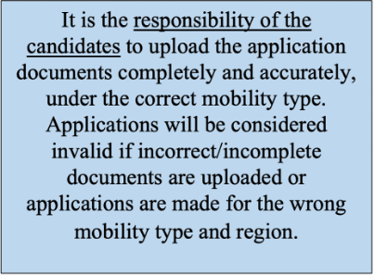

4. Selection Criteria
To find more information on the selection criteria used in the Erasmus+ Staff Mobility applications, please see the below.
CRITERIA | POINTS | DESCRIPTIONS
Number of Previous Participations in the Applied Program
First time | +20 | Previous participation in staff mobility for Academic and teaching programs will be evaluated together.  Those staff who have been selected in the previous application calls but have not completed his/her mobility yet will also be evaluated as the previous participants.

Withdrawal
Previous application period | -10 | The overall score of the participants who have been selected and granted in the previous application period and withdrawn from the program due to a cause except the force majeure and health issues will receive a 10 pts penalty for each of their withdrawals. Withdrawals from staff mobility for Academic and teaching programs will be evaluated together.
Application to More than One Program in the Same Application Period
Application to more than one program in the same application period | -10 | Applicants who apply to the Erasmus+ Staff Mobility for Academic and Teaching Programs at the same time in the same application period will receive -10 for the mobility program that they do not prioritize.
Number of Years of Service in Altinbas University *
10 and above | +10 | in all departments and positions of the applicant (only at Altinbas University)
5-10 | +8
2-5 | +6
1 | +5
Other Criteria
Applicants with Disabilities | +5 | A health report proving disability must be submitted during the application.
Veteran Staff or Spouse/ Children of Veterans/Martyrs | +5 | Documents proving the condition must be submitted during the application.
Those applicants who themselves or their first-degree relatives receive disaster aid from AFAD | +5 | Documents proving the condition must be submitted during the application.
Activities related to Artificial Intelligence within the scope of the National Artificial Intelligence Strategy * | +5 | Documents proving the condition must be submitted during the application.
If you have worked as an Erasmus Department Coordinator before | +5
If you are currently working as an Erasmus Department Coordinator | +10
Activities to develop Digital Skills * | +5 | Documents proving the condition must be submitted during the application.
Hold related visa | +5 | Documents proving the condition must be submitted during the application.
International Projects (Erasmus+, Horizon, ESC, Tubitak, etc.) conducted in the last 2 years | +5 | Documents proving the condition must be submitted during the application.
Language score of Proff., Assoc. Prof., and DR faculty member titled will be proceeded as 70 in case of non-delivery of language proficiency exam document. | B2 and above +10
Graduating from an institution with a medium of instruction % 100 English high school and/ or university will be evaluated as a 70 score out of 100 | B2 and above +10 | Documents proving the condition must be submitted during the application.
YOKDIL, EYDS, YDS, EYOKDIL valid until 5 years 60-69 score out of 100 | B1 +5 | Documents proving the condition must be submitted during the application.
An applicant who wants to participate in a country that holds citizenship | -10
If more than one staff have the same overall point;
- Applicants who have less previous participation will be prioritized.
- Applicants with a longer period (day, month, and year) of service ina Altinbas University will be prioritized.

*Details of activities for the development of artificial intelligence and/or digital skills are explained in the selection criteria document, and candidates who will participate in such an activity must specify the type of activity in question in their acceptance letters and Teaching/ Academic documents. Candidates who do not include details of activities for the development of artificial intelligence and/or digital skills in their documents will not be awarded additional points in this category.
5. Duration of the Activities

According to KA171 program rules, the duration of academic mobility ranges from 5 days (min.) to 7 days (max.) excluding travel time. To learn the maximum duration of the academic activity that can be funded, please check the Partner list for this call.

Please be aware that the partner list and the total budget for maximum weeks are subject to change and they might be updated during the application period. While evaluating the application results, the total budget for a maximum of weeks may increase depending on the availability of budget that may become available through the length of other mobility types and applicants/participants’ withdrawals. Also, if a new inter-institutional agreement gets signed, this agreement will be added to the list during the application period.

Important Remarks:

1. If the teaching activity hours last less than the minimum requirements (min. 5 consecutive days) the Erasmus+ mobility will be considered invalid by the funding body. In this case, the grant payment will not be made for the related activity.

2. The activity must be completed by the next application period, which is 31 July 2025. The beneficiaries can't conduct their mobility afterward.

6. Erasmus+ Funding

6.1. Daily Grant Amounts

Daily Grant: 180 € per day for all countries.

A daily grant is allowed for teaching days and travel days up to 2 days.

Even if the travel days exceed 2 days, beneficiaries can't receive daily grants for more than 2 days of travel. To provide Erasmus+ funding for the travel days, the travel should take place outside of the teaching days.

6.2. Travel Amount by Distance
In addition to daily grants, participants will receive travel support as well.

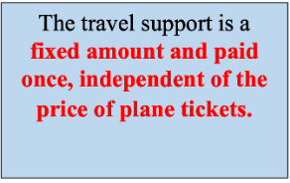

The travel amount is calculated by using the “Distance Calculator” below:
http://ec.europa.eu/programmes/erasmus-plus/tools/distance_en.htm

The distance calculator is used to determine the distance between the location where the staff is residing and the place of activity. The kilometers in distance calculated by the distance calculator corresponds to the round-trip and the amount does not get multiplied by two.

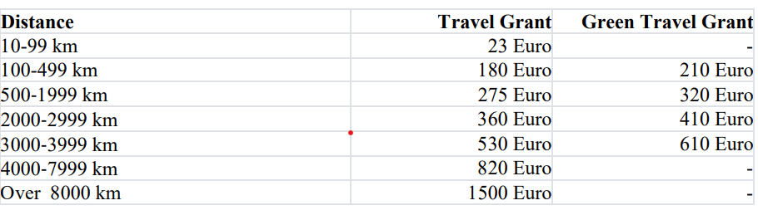

*Green Travel
In case the staff member prefers sustainable means of transport in both directions (e.g. using the railway, maritime transport, car-pooling with other Erasmus+ program beneficiaries, or using the bus), the distance-based travel grant is considered as green travel. The grant amount is calculated according to the relevant part of the table. Whether the staff member can be considered within the scope of green travel is determined by the submission of the relevant travel documents to the Erasmus Office and the evaluation of the Turkish National Agency.

6.3. A Sample of Grant Calculation
A visit to Albania for 1 week (5 days of Academic & 2 days of travel):
Total grant = 180*7 (mobility days) + 275 (travel support) = 1535 €.
Please be informed that participants receive 80% of the total financial support at the beginning of their mobility period and the remaining 20% when the academic program is over.
Please also be kindly reminded that participants are responsible for arranging their travel and the Altinbas University Erasmus Office is not responsible for travel arrangements and purchasing plane tickets.
Mobility activities that cannot be carried out due to possible problems in travel arrangements will be deemed invalid and the grant payment made to the beneficiary will be expected to be refunded.
7. Additional Grant for Disadvantaged Participants
The Erasmus+ Program encourages the participation of participants with limited means. A person with limited means is a potential participant whose personal physical, mental, or health condition does not allow him/her to participate in the project/mobility activity without additional financial support. For a beneficiary in need of inclusion support to be given an additional grant, the beneficiary higher education institution must request an additional grant from the Center.
An increase in the grant cannot be requested after the participant's activity ends.
8. Erasmus Staff Mobility without Grant (Zero-Grant)
It is possible to participate in the Erasmus+ KA171 program without getting any grant. Those staff members who would like to participate in the program on a zero-grant basis need to apply to Erasmus Office under the current call and their applications will be evaluated along with all the others. Those participants with zero grants also must fulfill the obligations of the program.

9. Contact
If you have any questions about the Program, you can contact Altinbas University Erasmus Office: icm@altinbas.edu.tr.

