How to apply?
Candidates are required to access Altınbaş University's ERASMUS+ KA131/171 STUDENT/INTERSHIP MOBILITY announcement page by logging into the e-Government Application Portal with their T.C. Identity Number or YKN Identity Number and carry out the application procedures as specified in the application guide. Applications for Learning Mobility and Internship Mobility are received and evaluated separately. Applications for Learning Mobility and Internship Mobility are received and evaluated separately.
You need to use Google Translate for all steps because the e-Government system is Turkish.

Step 1: Candidates are required to access Altınbaş University's ERASMUS+ KA131 STUDENT/INTERSHIP MOBILITY announcement page by logging in to the e-Government Application Portal with their T.C. or YKN ID Numbers and carry out the application procedures as specified in the application guide.
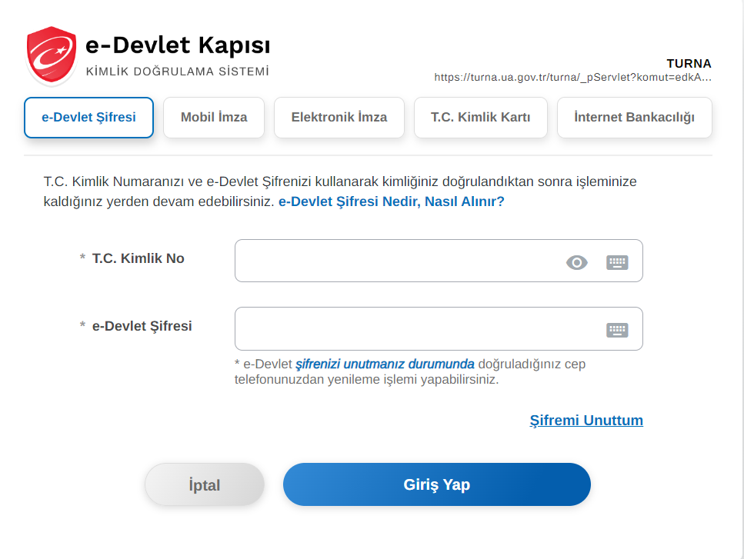
Step 2: Please select the related active application.
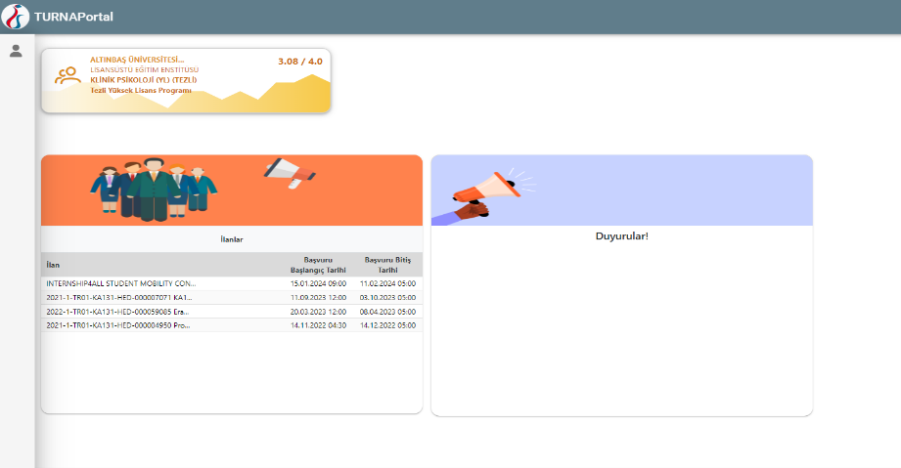

Step 3: Select başvurularım then click Başvuru Yap
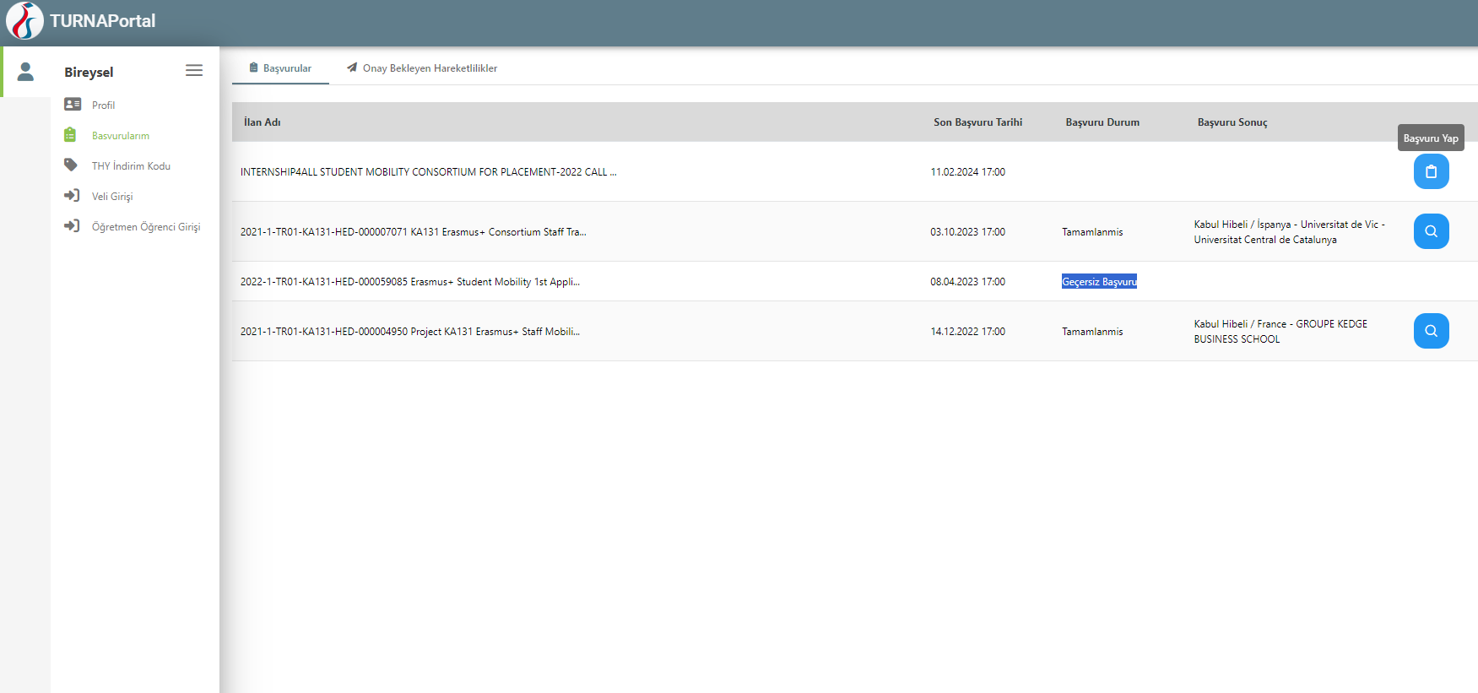
Step 4: Click I Agree
