Erasmus+ World KA171 International Credit Mobility
Outgoing Student Applications
for 2024-2025 Academic Year
2022-1-TR01-KA171-HED-000075524

INFORMATION SESSIONS:
For the details of online Information sessions, you can visit the link below:
08.05.2024 11:00-12:00 online (click here). English
09.05.2024 14:00-15:00 online (click here). Türkçe

APPLICATION CRITERIA
Please note that this application is NOT for Erasmus+ with European Countries.
Students can apply for Erasmus+ World KA171 International Credit Mobility – ICM) only if:
- CGPA is at least 3.00 as of the application deadline (undergraduate level)
- CGPA is at least 3.50 as of the application deadline (graduate level)
- B2 level of English (English Proficiency Exam result, TOEFL, YDS, and YÖKDİL are required)
Please bear in mind that:
-Undergrad students should have an Altınbaş University (AU) course load of a minimum of 30 ECTS for the semester in which s/he plans to participate Erasmus Programme.
- The students who is studying preparatory class can not apply.
-Those ONLY MS and PhD students who completed their course load and in the thesis period can also apply as their thesis satisfies the ECTS requirement. AU will check the course loads of the applicants. The second option Master and Ph.D. students may take a minimum of 20 ECTS courses however after completing their coursework, qualification, and thesis proposal processes, doctoral program students can participate in mobility during the thesis stage. The student going through the thesis stage must register for the thesis course through the course registration page of Altınbas University during the course registration period specified in the academic calendar before participating in mobility. During mobility, they must complete a minimum of 20 ECTS credits of thesis work under the supervisor of the host institution. At the end of the semester, The instructor will give a reference letter demonstrating students’ minimum 20 ECTS credits of work within the scope of their thesis research.
-Undergrad students Should take 30 ECTS courses/or 5 courses (when the host university does not use ECTS) at the host university.
Applicants must be registered at AU as full-degree students at the time of application.
The student must have completed at least 1 semester in the program they are enrolled in. During the application, the student must have a cumulative grade point average (CGPA) in their program.
Exceptional situations:
*The evaluation will be based on the course number where the partner institution is not using the ECTS system. For such universities, the students must pass at least 3 of their courses out of 5.
- The courses which are taken at the partner institution must be recognized.
- The course grades FF / FD / W are not hindered for applications. However, the students with these grades must consider regulations and departmental policies, which may affect their participation in the program. Furthermore, these FF / FD / W grades may influence the host university’s decision to accept these students.
- It is obligatory to have a valid English score to complete the application. Detailed information about English language scores can be seen in the application call.

Application Period: 13.05.2024 – 03.06.2024
Announcement of Application Results: to be announced in June 2024

APPLICATION METHODS:
All applications, selections, and placements will be carried out online and through the E-Devlet Gate platform initiated by the Turkish National Agency: https://turnaportal.ua.gov.tr/giris
Students must submit their application online between 13.05.2024 and 03.06.2024 to the E-Devlet Gate platform. The application platform will be closed on 3 June 2024 at 23:59 and you will not be able to upload any documents or make any changes in your application after this time. (please find the guide for application from the link.)
Additional application documents (e.g. the health report for disability) should not be physically transmitted, but uploaded to the relevant section of the Application Portal.

ENGLISH PROFICIENCY EXAM:
The Alumni Relations and Internationalization office is no longer holding the English Proficiency Exam However, students interested in applying to Erasmus+ World programs will be able to bring English language scores taken within the last 5 years before the application period. These scores must be one of the AU-recognized exams. Please check which exams are recognized below and prepare your valid score. You can submit your English Proficiency Exam, Preparatory Exam, YDS, E-YDS, YOKDIL, E- YOKDIL, TOEFL.
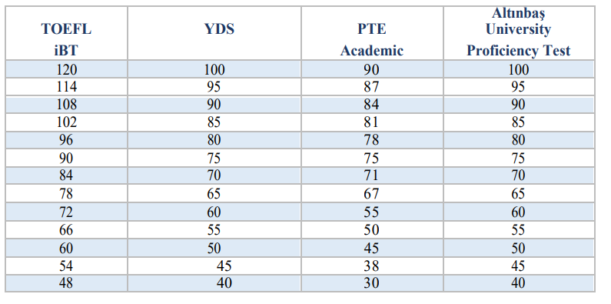

PARTNER UNIVERSITIES:
At most 2 universities can be chosen. The list of partner universities, Fact sheet, and country quotas can be seen HERE.
* Please be aware of that, due to the quota of the agreements, there are only one quota for each universities, and the student who get highest point of Erasmus score will be placed.
While checking the University list, please be aware that some countries are available only for PhD-level students. This is the requirement of the Erasmus+ ICM Program and it is announced by the European Commission for the current project. For those countries, it is not possible to send Undergraduate and Master students with Erasmus+ grants. However, this does not mean that universities open to the applications of PhD students have PhD level programs for sure; students must check the University websites and fact sheets and be sure that there is a suitable program and course list convenient for their academic program and level.

It is of utmost importance to consult the departmental coordinator about the university choices. A list of departmental exchange programs coordinators can be found at the link ‘’ who is my coordinator’’ section.

All Students must be sure that the university they applied to offers education at their level and in a relevant department. The availability of a university in the list does not imply that the university offers education in all the departments and on all levels of education. To apply to the universities does not guarantee that the university accepts you. The applicants are required to check the conditions of the partner universities (i.e. medium of instruction, language requirement, academic calendar, accommodation opportunities, etc.) before submitting their applications.

During application, an internationally recognized language proficiency exam grade is not required by AU. However, partner universities may require a language proficiency exam grade document for their language of education (TOEFL, IELTS, etc.). The students can't study in a university if they cannot meet the language requirements for the university. Since language proficiency requirements differ among universities, it is necessary to check the university’s website for the language requirements before application and to make sure the language requirements can be fulfilled/documented before the deadline.

Agreements within the framework of the Erasmus+ ICM Program are generally established as “mutual departments”. This means that all students can apply, and no one is given priority over the others unless stated otherwise in the “Restrictions” section of the agreement list in the announcement. However, before applying for those universities, please make sure that there is a department (or at least courses) at the partner university corresponding to your department and level at AU.

SELECTION CRITERIA:
50% of CGPA and 50% of the English language test score are taken into account in electing prospective Exchange students.
▪ Applicants with disabilities (approved by a medical report) get 10 additional points. Medical reports concerning their disability must be submitted to the online application system during the application period.
▪ 15 points will be added to the overall score of the students who are the children of martyrs and veterans. The proving documents must be submitted to the online application system during the application period.
▪ 10 points will be added to the overall score of the students who have been under protection by 2828 Social Services Law. The proving documents must be submitted to the online application system during the application period.
▪ It is possible to benefit from the Erasmus+ Programs (Erasmus European Study, Erasmus Traineeship, Erasmus+ Non-European ICM) more than once. Students can participate in the programs for up to 12 months for each level of study (UG, MS, PhD). However, 10 points will be deducted from the overall grade of the students who have benefited from Erasmus+ before within the same study level. Previous participation in the program in different study levels does not cause any deduction in the overall grade.
▪ 10 points will be deducted from the overall grade of the students who have withdrawn from the program after the announced deadline for the previous Erasmus+ Non-European ICM Program Applications.

To qualify for extra points, students must submit the relevant documents at the time of application. Benchmark scores will be applied to the Erasmus score.
• (-) Students who wish to participate in the program in their countries of citizenship
• (-) Placed students who do not attend the mandatory orientation sessions without a valid excuse will have 5 points deducted if they apply for the Erasmus+ ICM again.
• (-) Students who participate in the ICM program at the same study level will have 10 points deducted if they apply again.
• (-) Students who withdraw from the program after submitting the commitment form will have 10 points deducted if they apply for the Erasmus+ ICM again.
• (+) Students with disabilities will be given an extra 10 points*
• (+) Students who are the children of Veterans/Martyrs will be given an extra 15 points**
• (+) Students whose first-degree relatives or themselves receive disaster victim financial support from AFAD will be given an extra 10 points.
• (+) Extra 10 points will be given to the students who are under protection, care, and shelter by the Act No. 2828 Social Services and 5395 Child Protection Law.
* The student must submit the Disability Health Board Report included in the "Regulation on Disability Assessment for Adults" published in the Official Gazette dated 20 February 2019 and numbered 30692.
**In addition to the spouses and children of war veterans and war martyrs, when applying for Erasmus+ mobility, priority is given to the spouses and children of public officials who, “while performing their duties domestically or abroad, or even after the termination of their status, become victims of terrorist acts, get injured, disabled, or killed” as outlined in Article 21 of the Law on the Fight Against Terrorism numbered 3713, dated 12/4/1991. Furthermore, in line with Article 7 of Decree numbered 667 dated 23 July 2016, priority is granted to civilians who became disabled, and the spouses and children of these civilians, as well as the spouses and children of those who lost their lives due to the coup attempt and terrorist acts on 15/07/2016, when applying for Erasmus traineeship mobility.

GRANT & EXPENSES:
- Selected students are exempt from paying a fee to the host universities. However, Exchange students who are responsible for paying a tuition fee will continue to pay school fees to AU; they are exempt from paying to partner universities.
- Students selected for this program with an Erasmus+ grant will receive 700 Euro per month (same for all countries)
- Travel support will change between 180€ and 1500€ according to the city of the university where the student will study. The distance between Istanbul and the specific city is calculated via the following link:
http://ec.europa.eu/education/tools/distance_en.htm
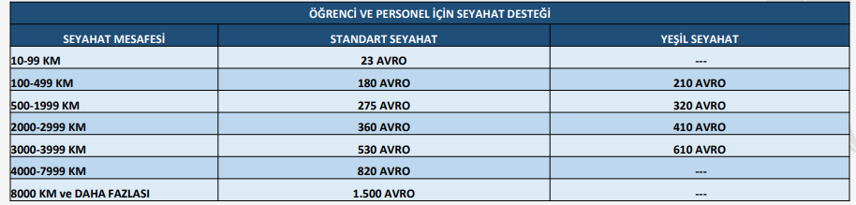

- Personal spending such as visa; book and stationery; food and drinks; and health insurance are the student’s responsibility.
- 80 percent of the grant payments are done before the mobility. The rest is paid after the student completes the program and returns to AU successfully.
- It is possible to participate in the program without a grant as well.

