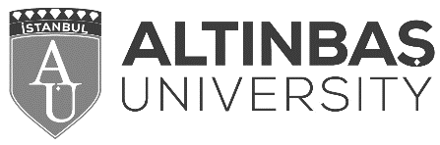

**Erasmus+ Student Mobility for Traineeship**

**Confirmation of Participation**

Herewith, we confirm that _________________________ enrolled at Altınbaş University has worked as a full time trainee at ________________________ in the framework Erasmus+ Student Mobility For Traineeship during the period indicated below:

Beginning Date : __________

Ending Date : __________

Name of the Host Institution: ____________

Name of the Supervisor : _____________

Signature of the Supervisor :___________________ Date: _______

Stamp : ______________