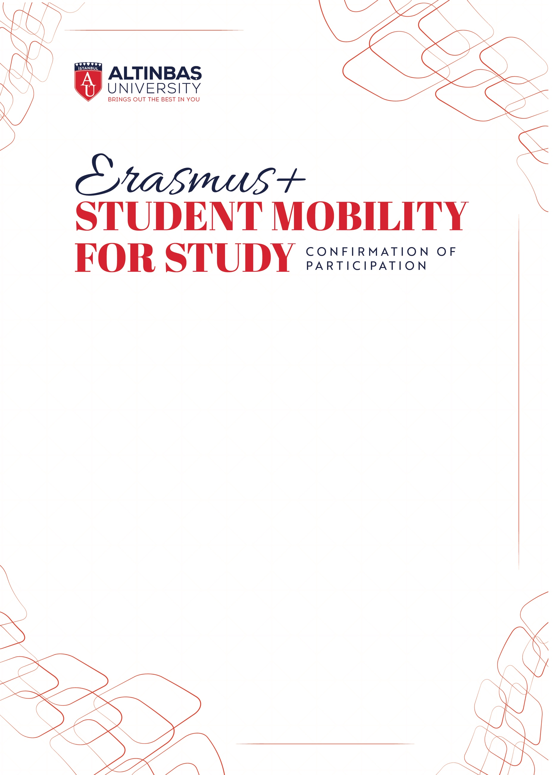

Herewith, we confirm that …………………. enrolled at Altınbaş University has studied as a full time student at …………………………. in the framework Erasmus+ Student Mobility For Study during the period indicated below:

Begining of the Courses / Orientation Program (if the student attended): ……………….

End of Final Exams : ……………….

Name of the Host Institution: ……………….

Name of the Erasmus Institutional Coordinator : ……………….

Signature of the Coordinator: ……………….
Date: ……………….
Stamp : ……………….

